Ben Nguyen

Professor Niall McCarthy

ISDA 20C

Feb 22nd, 2025

Accessibility

**Perceivable Principle**

* P1  
  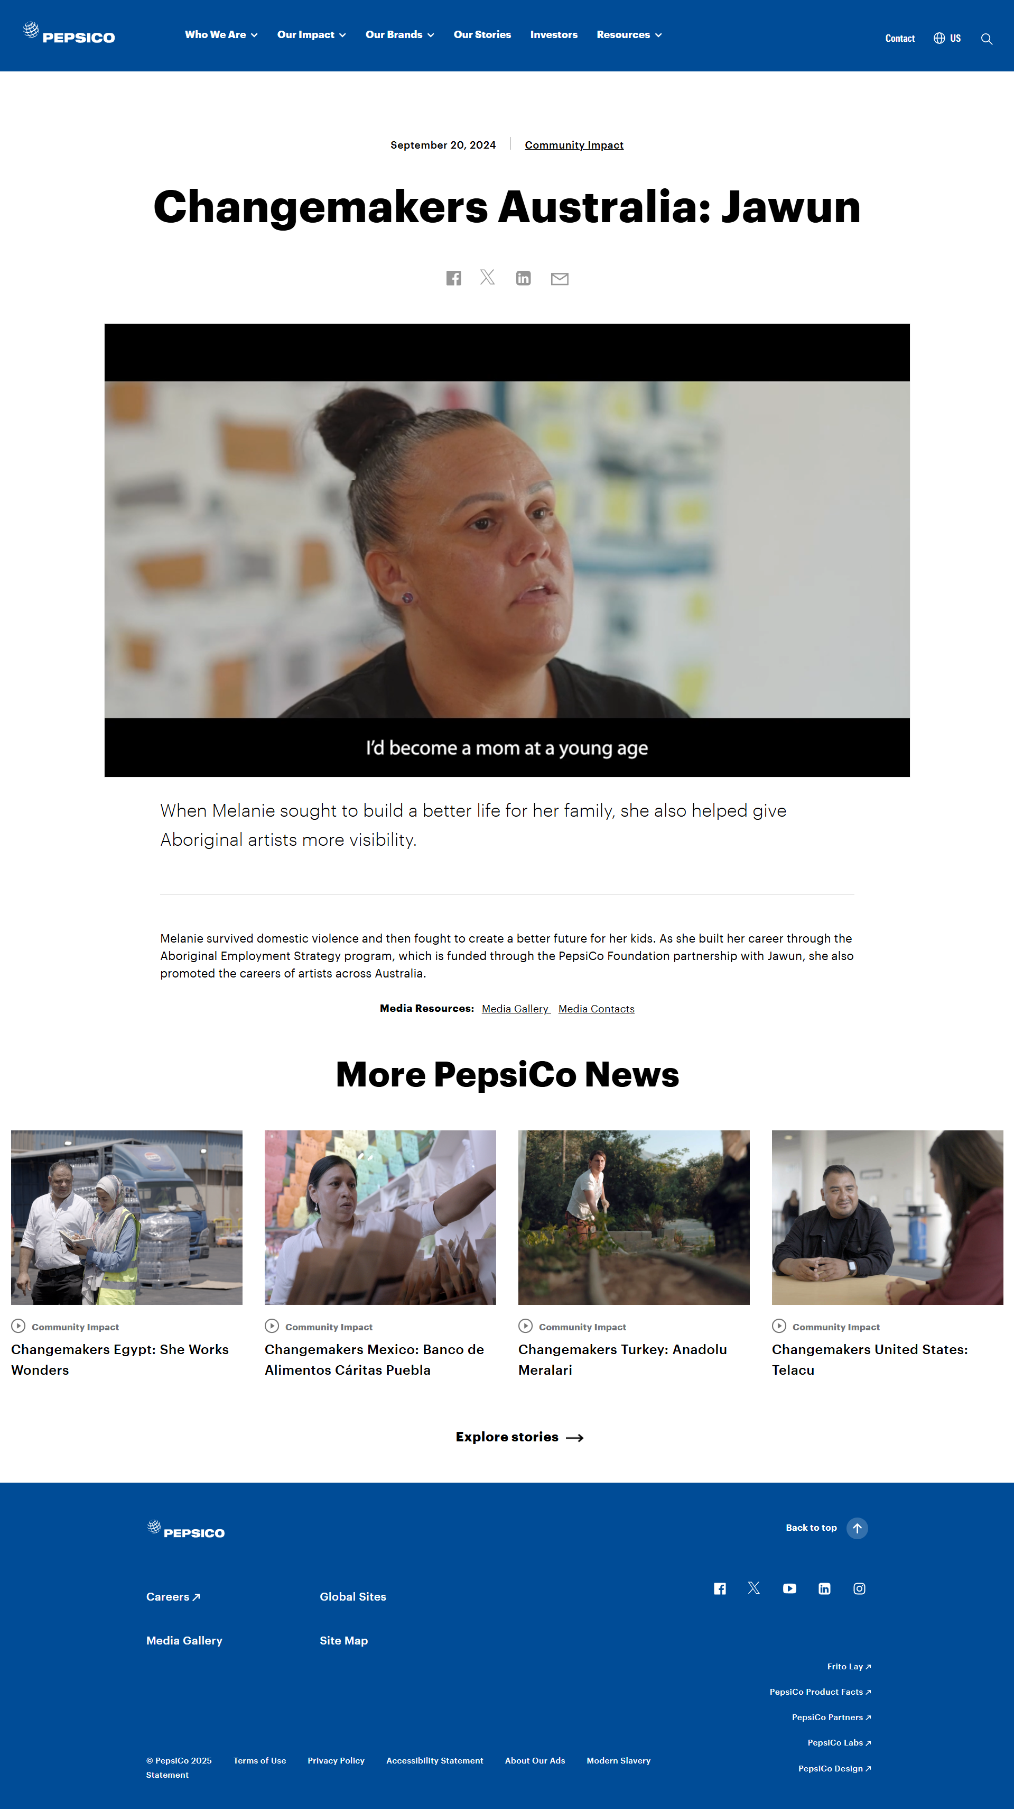
* P2  
  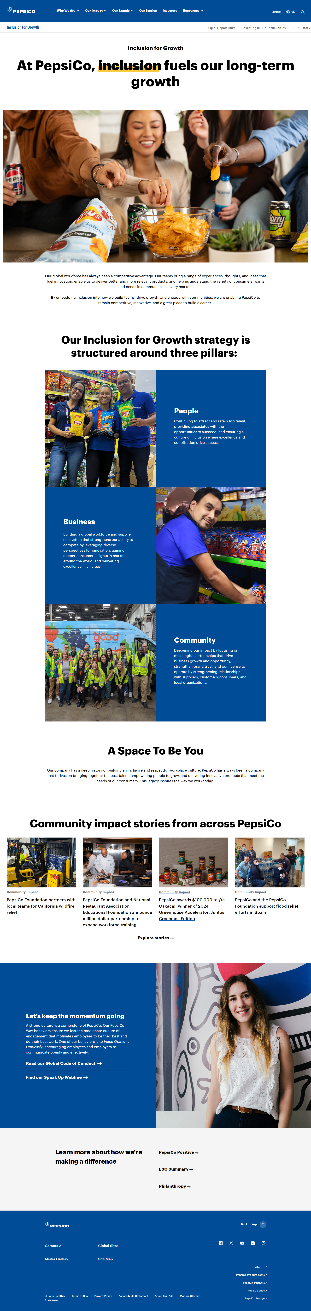

**Operable Principle**

* O1  
  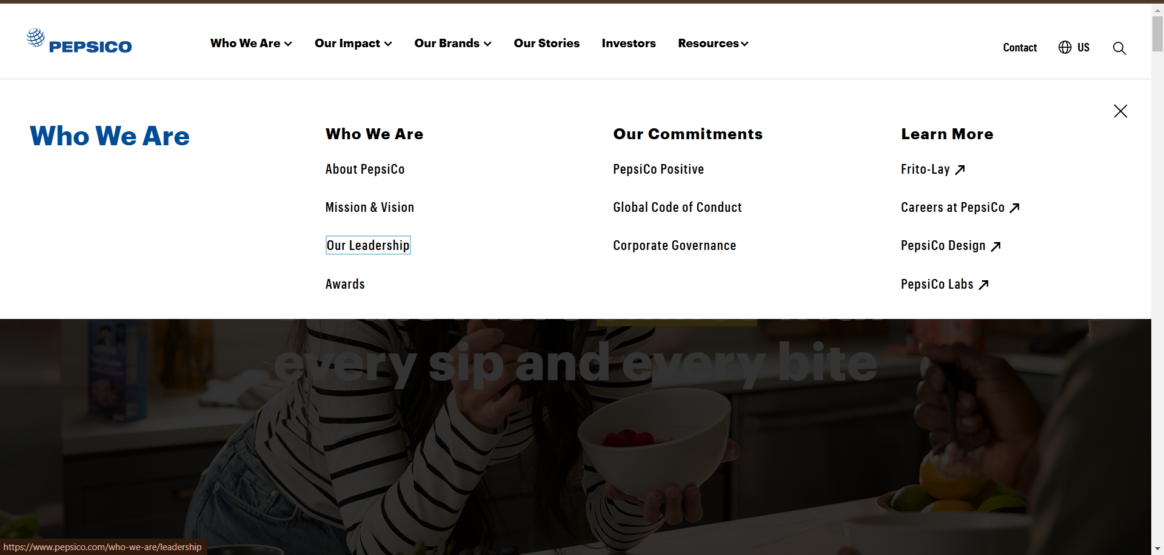
* O2  
  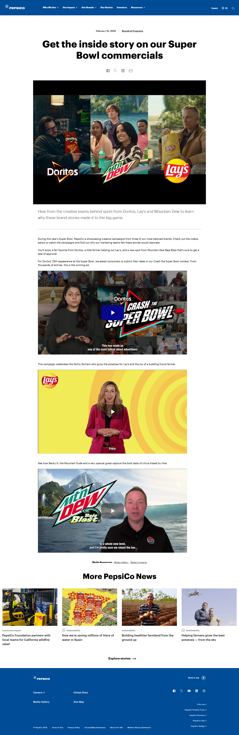

**Understandable Principle**

* U1  
  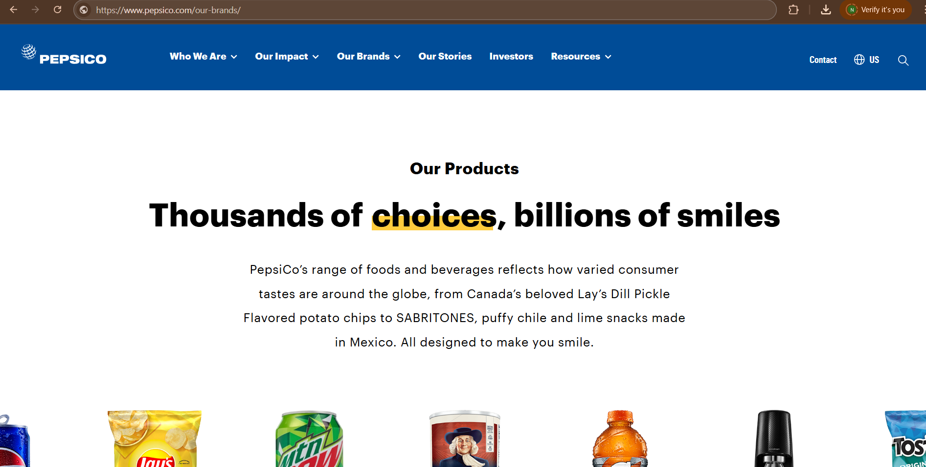
* U2  
  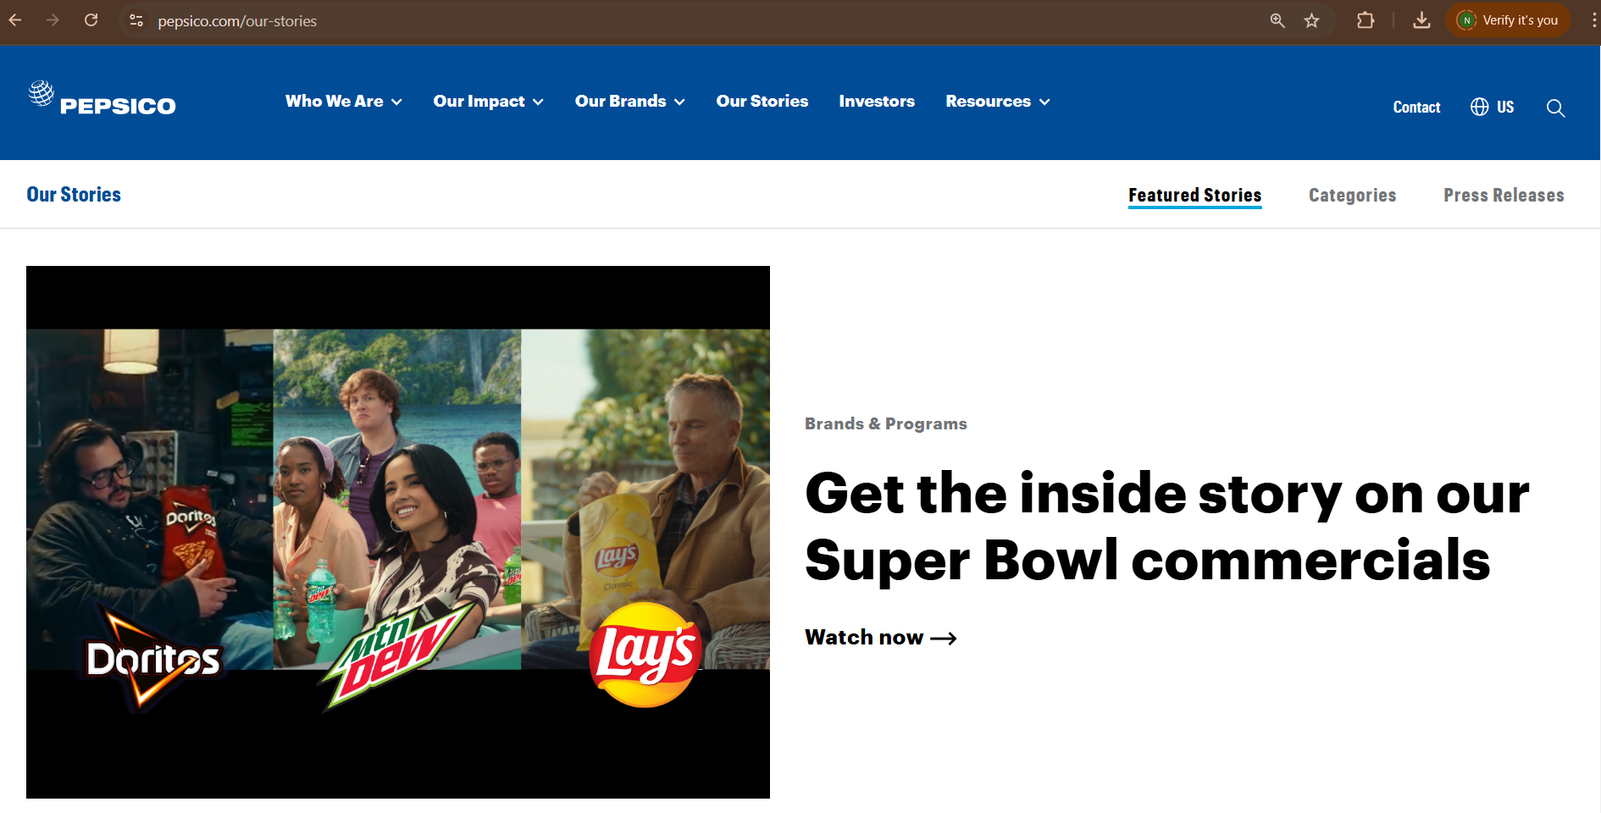
* U3  
  